**Create a VPC Endpoint and S3 Bucket in AWS**

Architecture**:**

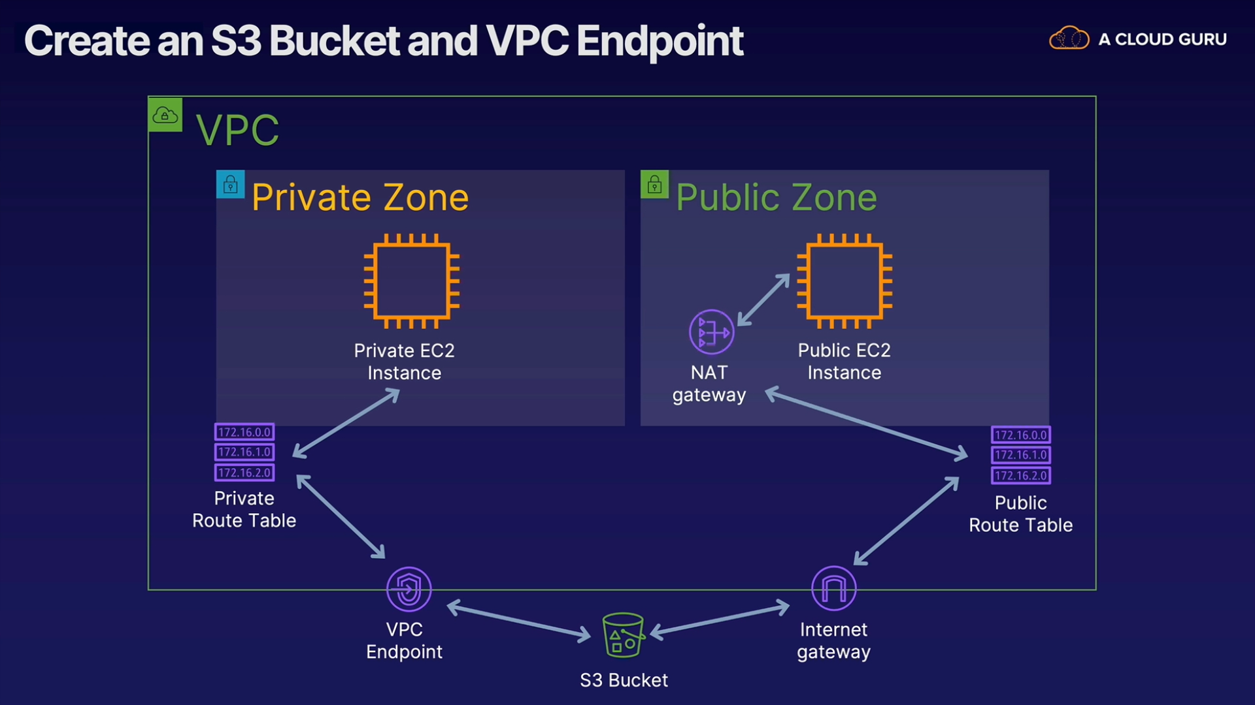

Create VPC

Create 2 subnet- public & private

Create 2 EC2 instances – public & private

Create 2 Route table – public & private

Create NAT gateway in public subnet & attach it to Route table

Create Internet Gatway and add it to public route table

Create S3 bucket

Create VPC endpoint

Create VPC

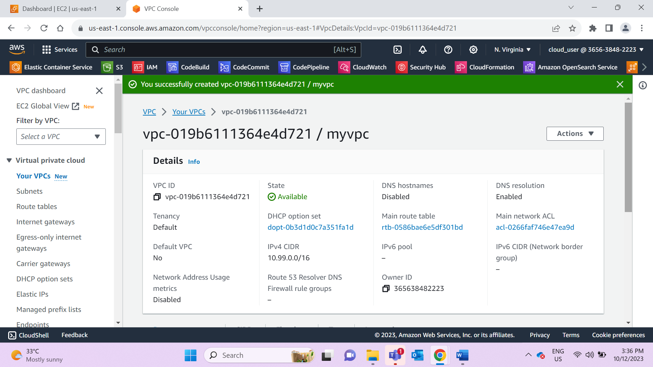

Create 2 subnet- public & private

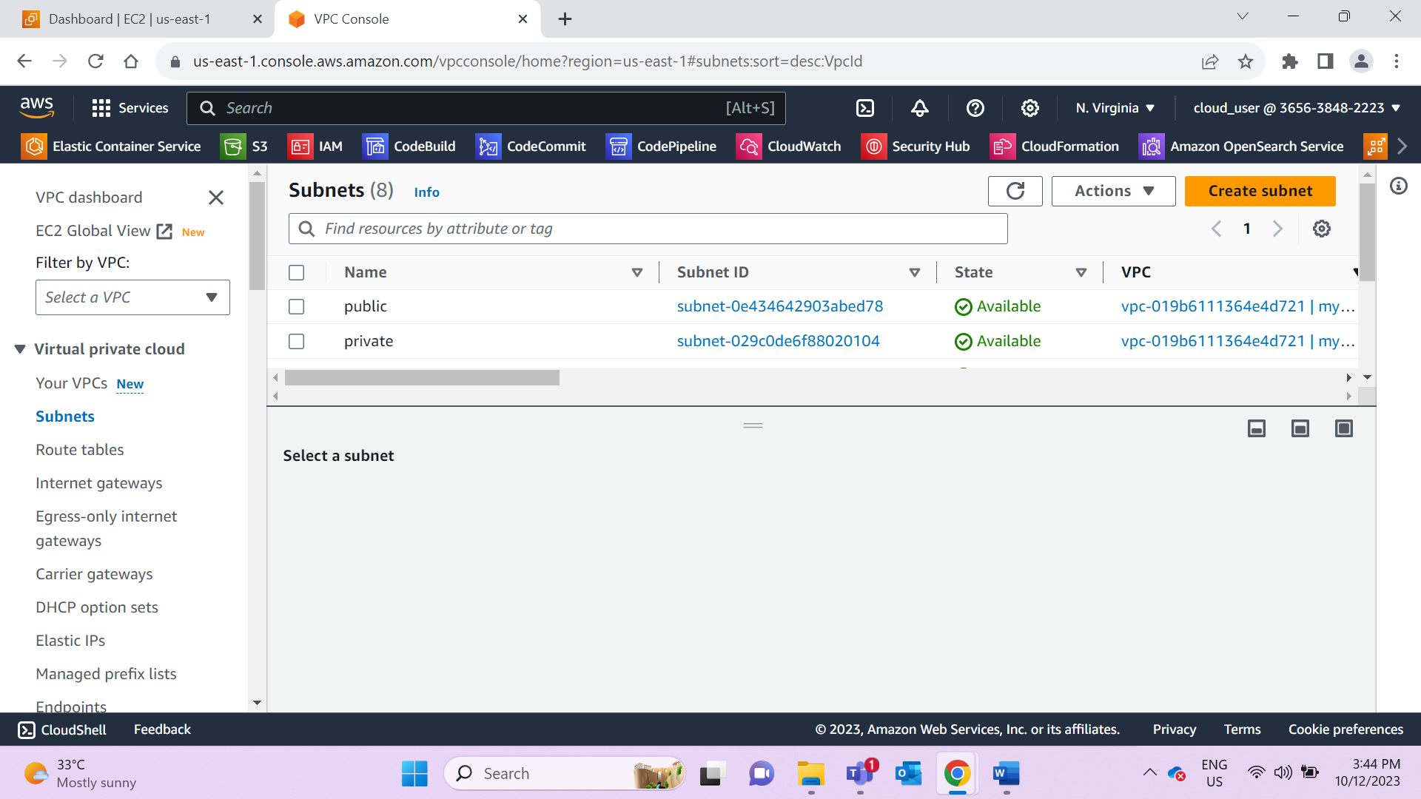

Create 2 EC2 instances – public & private

For public- Add VPC, public subnet, enable public IP address

For private- add VPC, private subnet, disable IP address option, attach public security group as source in private instance

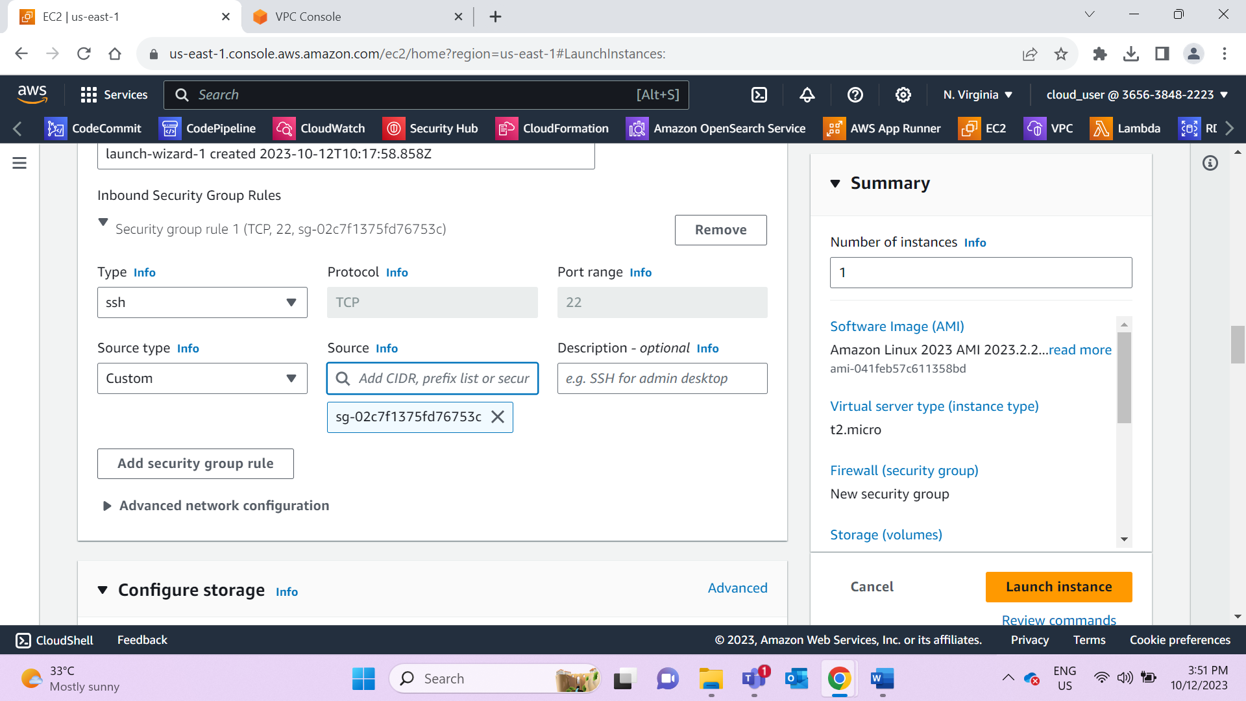

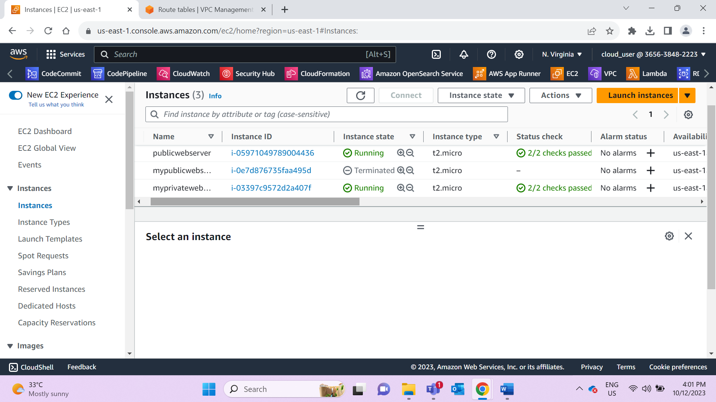

Private EC2 instance:

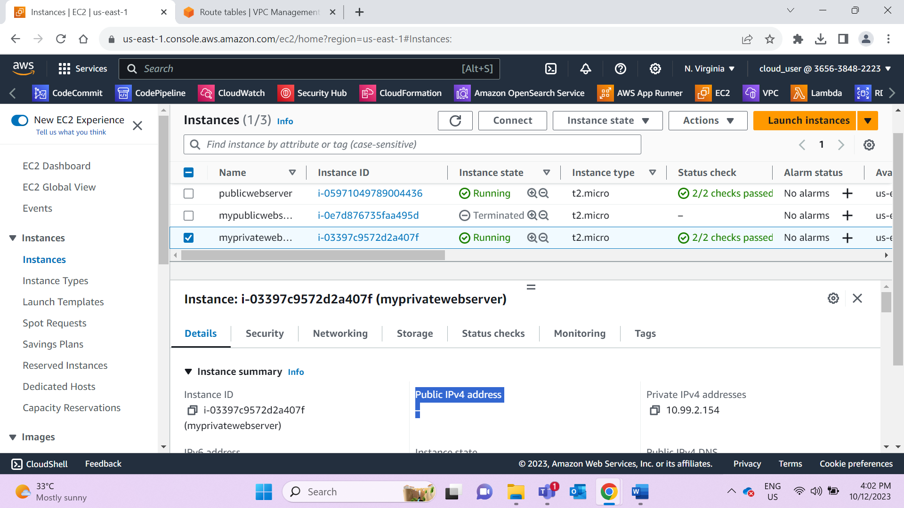

Create 2 Route table – public & private and associate with respective subnets

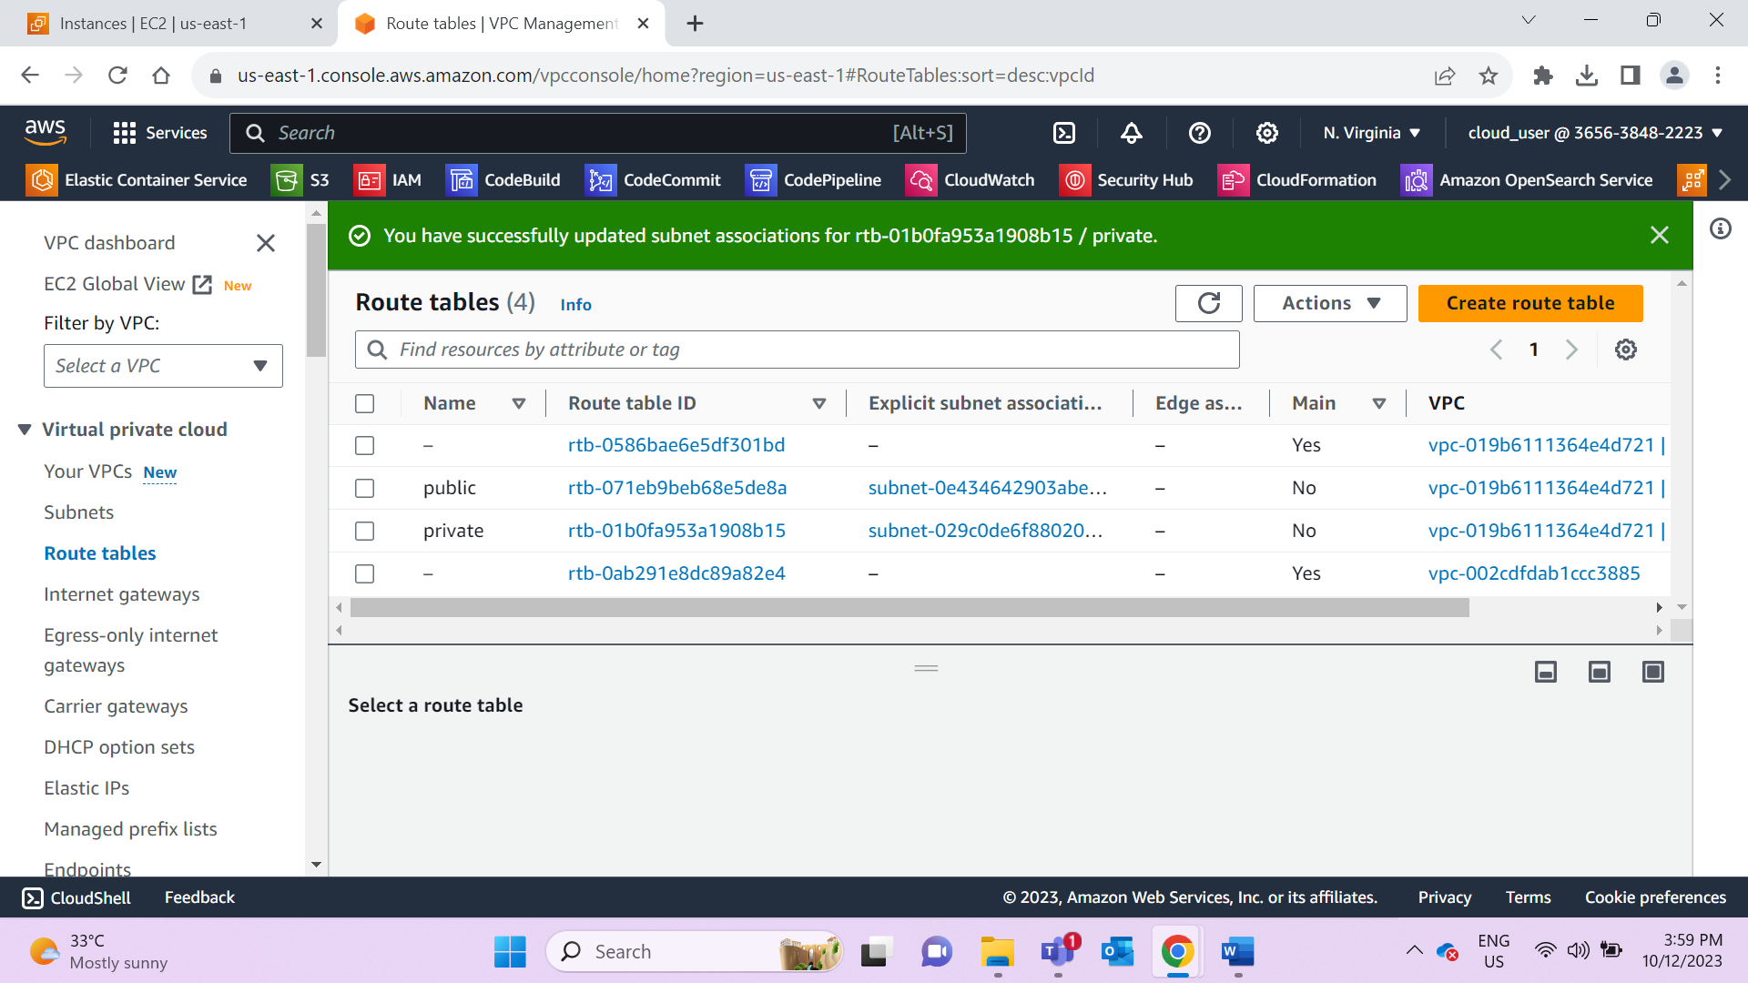

**NAT gateway -Do not create NAT gateway as we are using VPC endpoint**

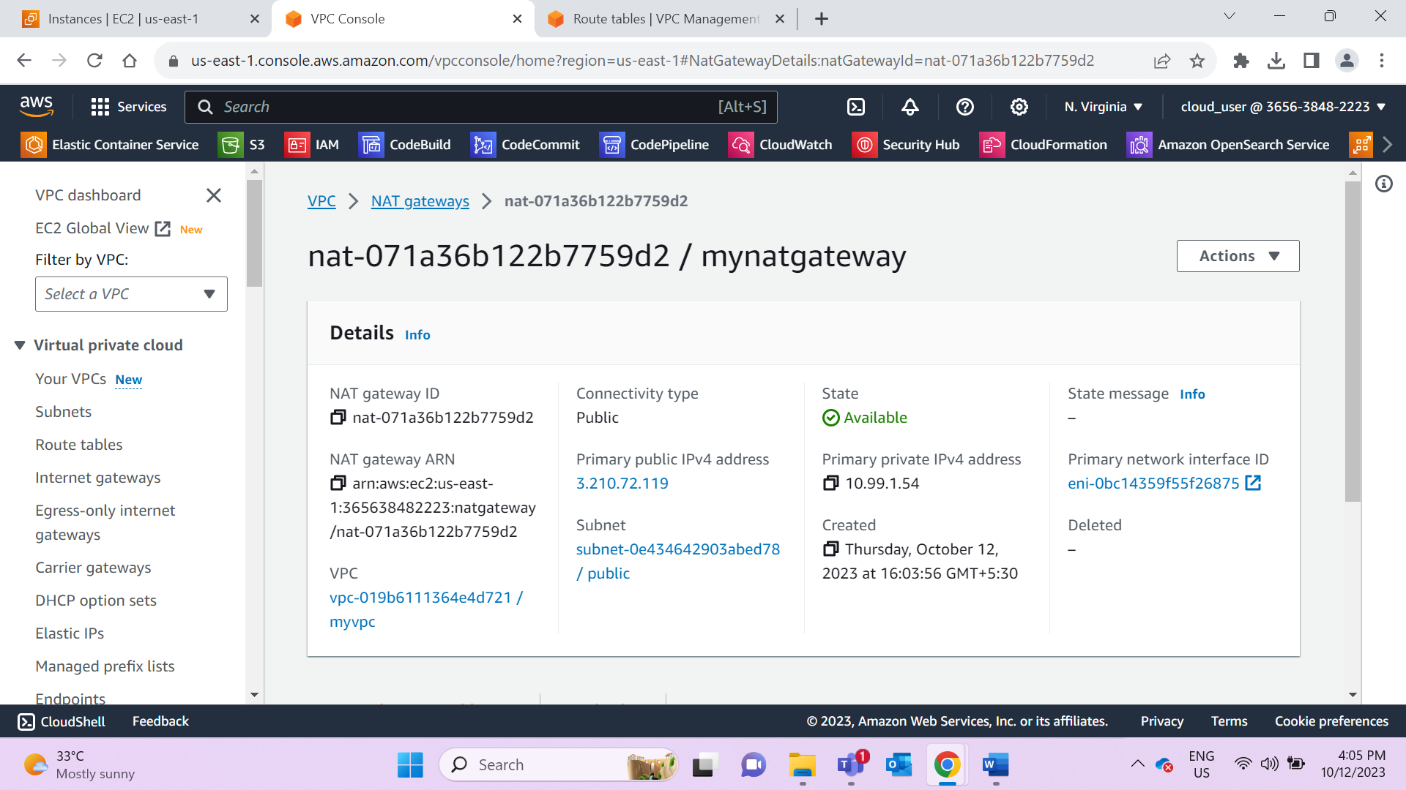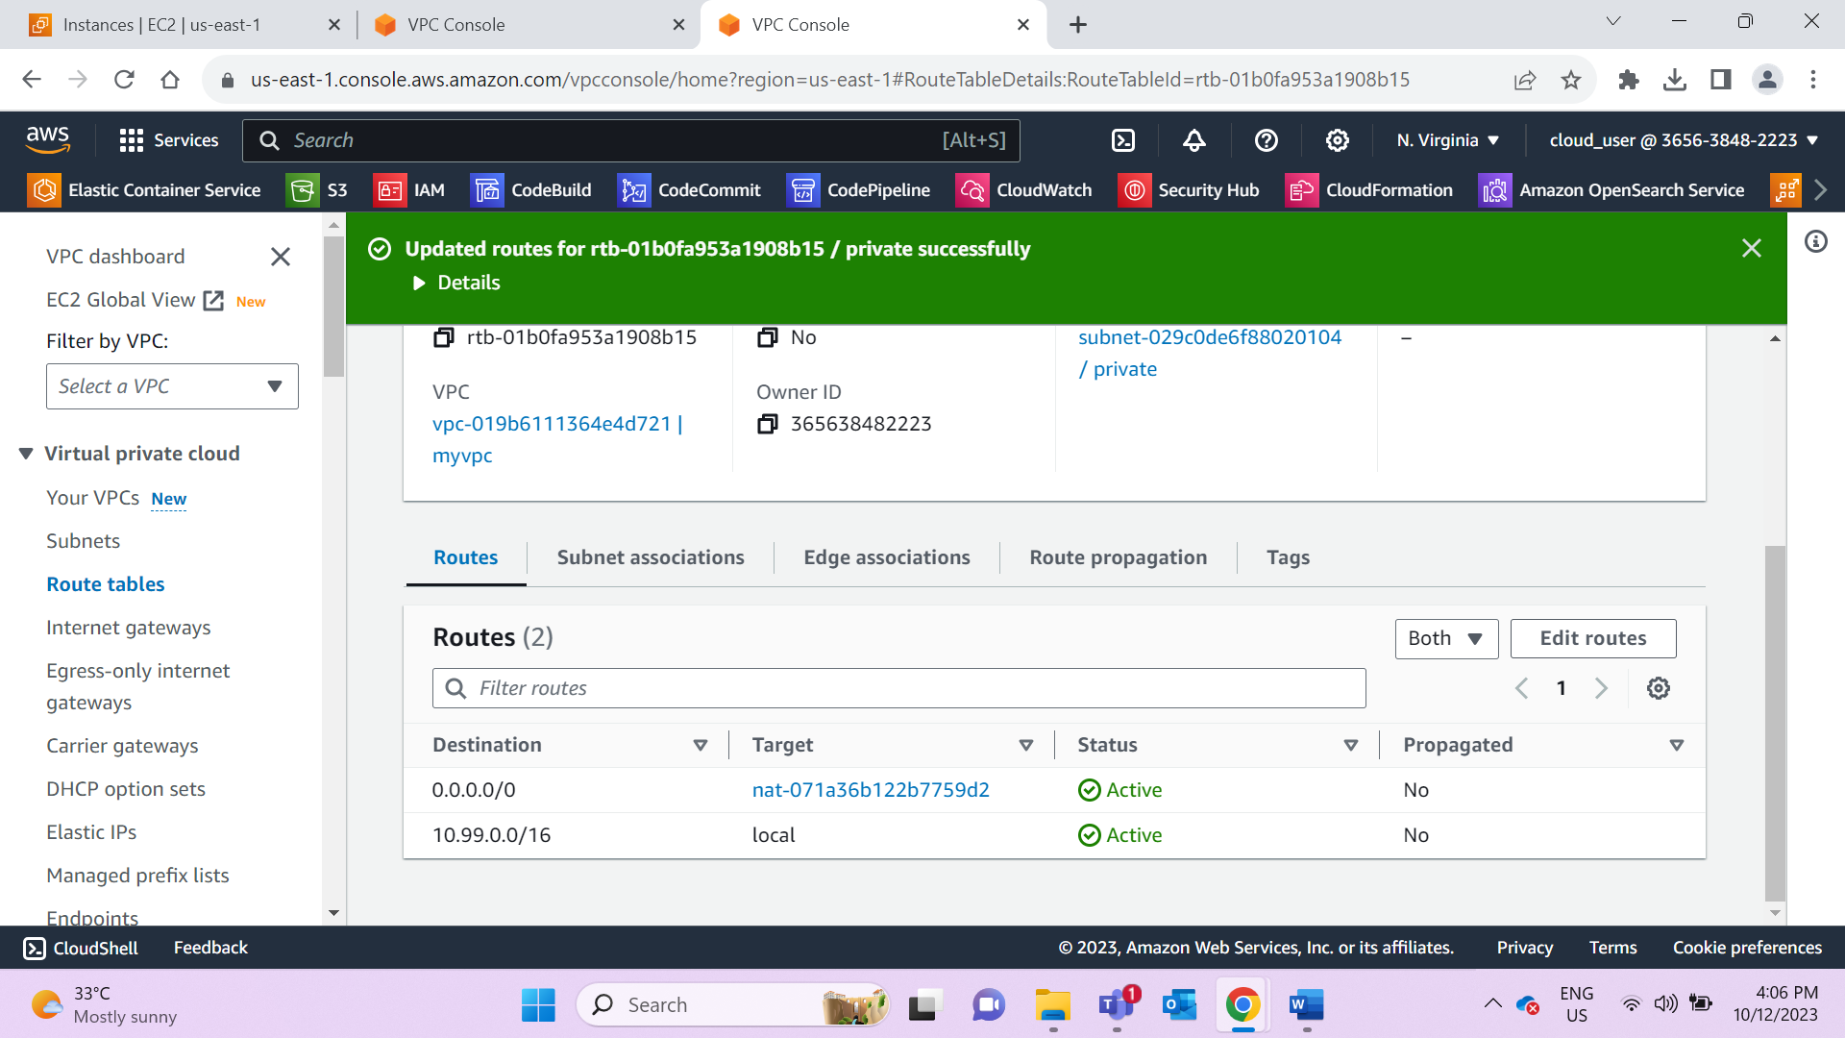

Create Internet Gatway and add it to public route table

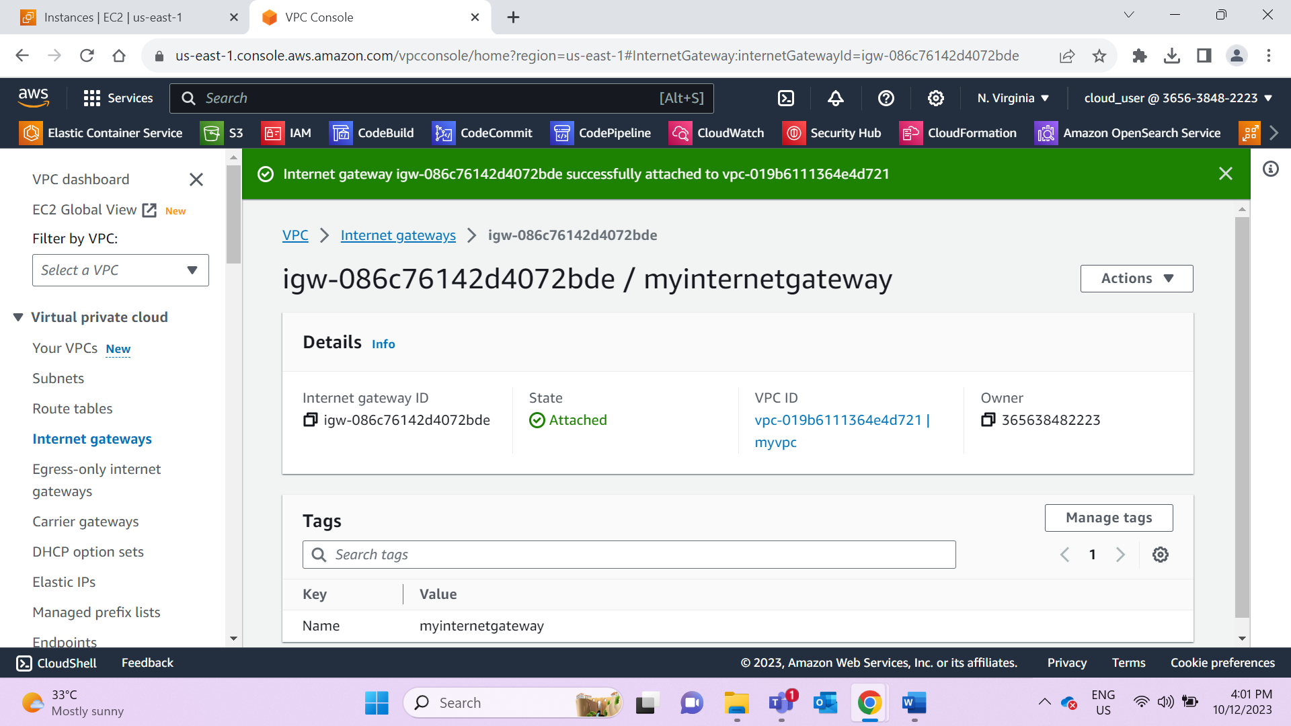

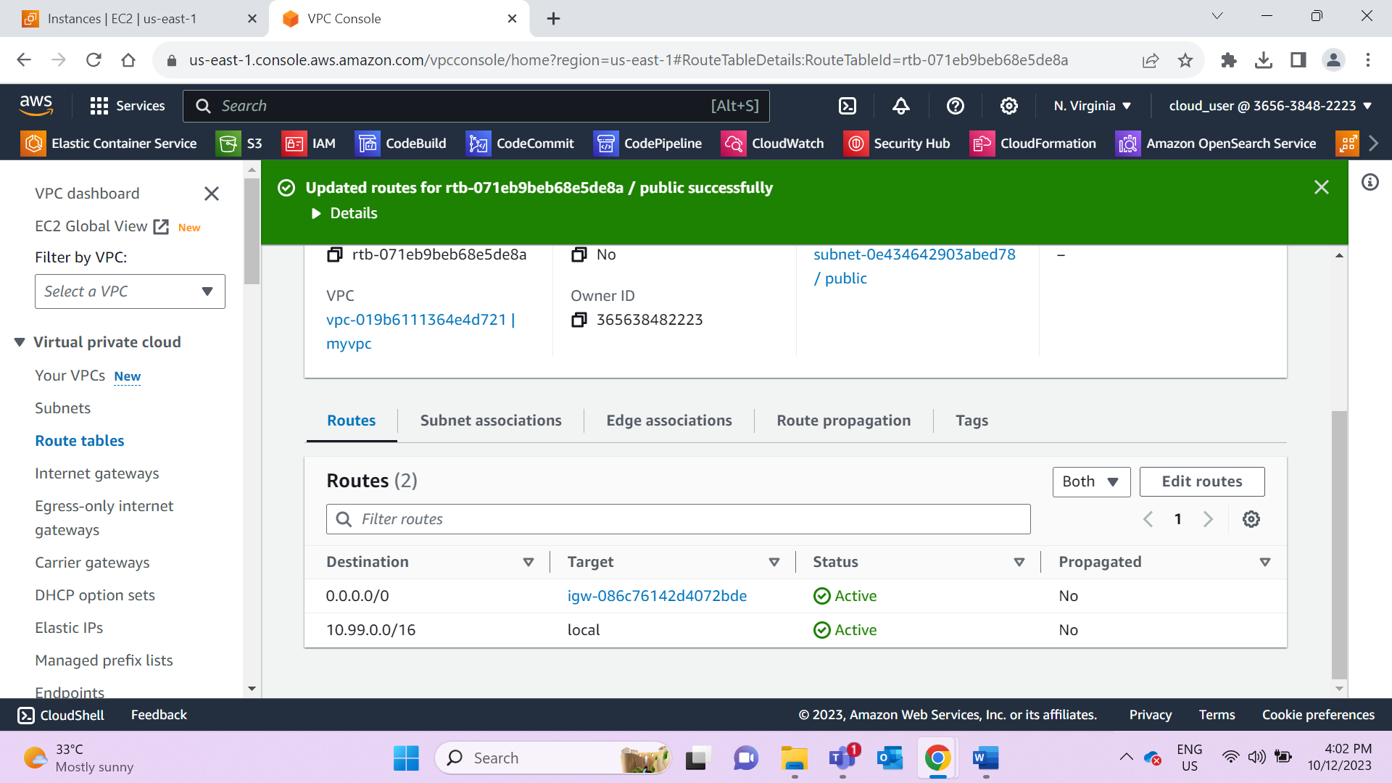

Create S3 bucket

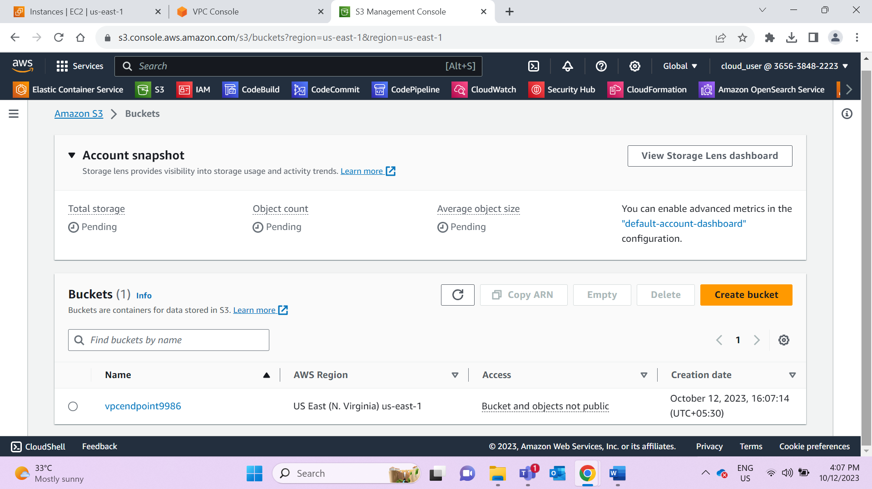

Create VPC endpoint

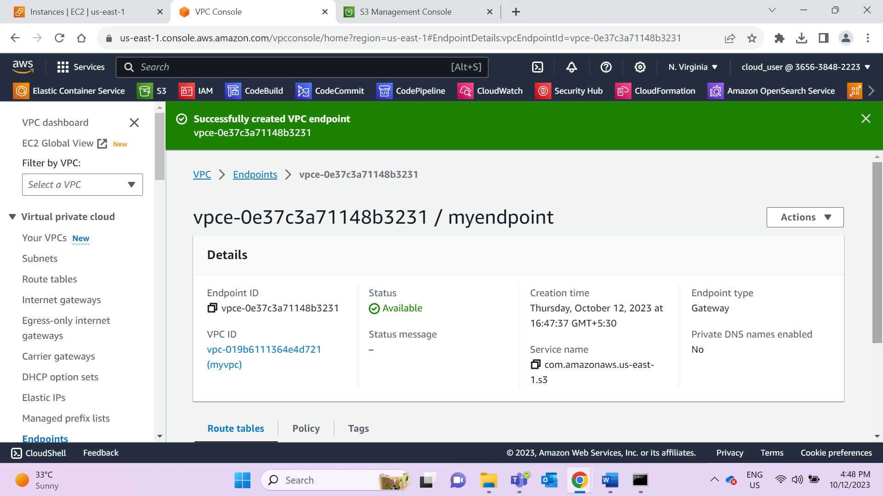

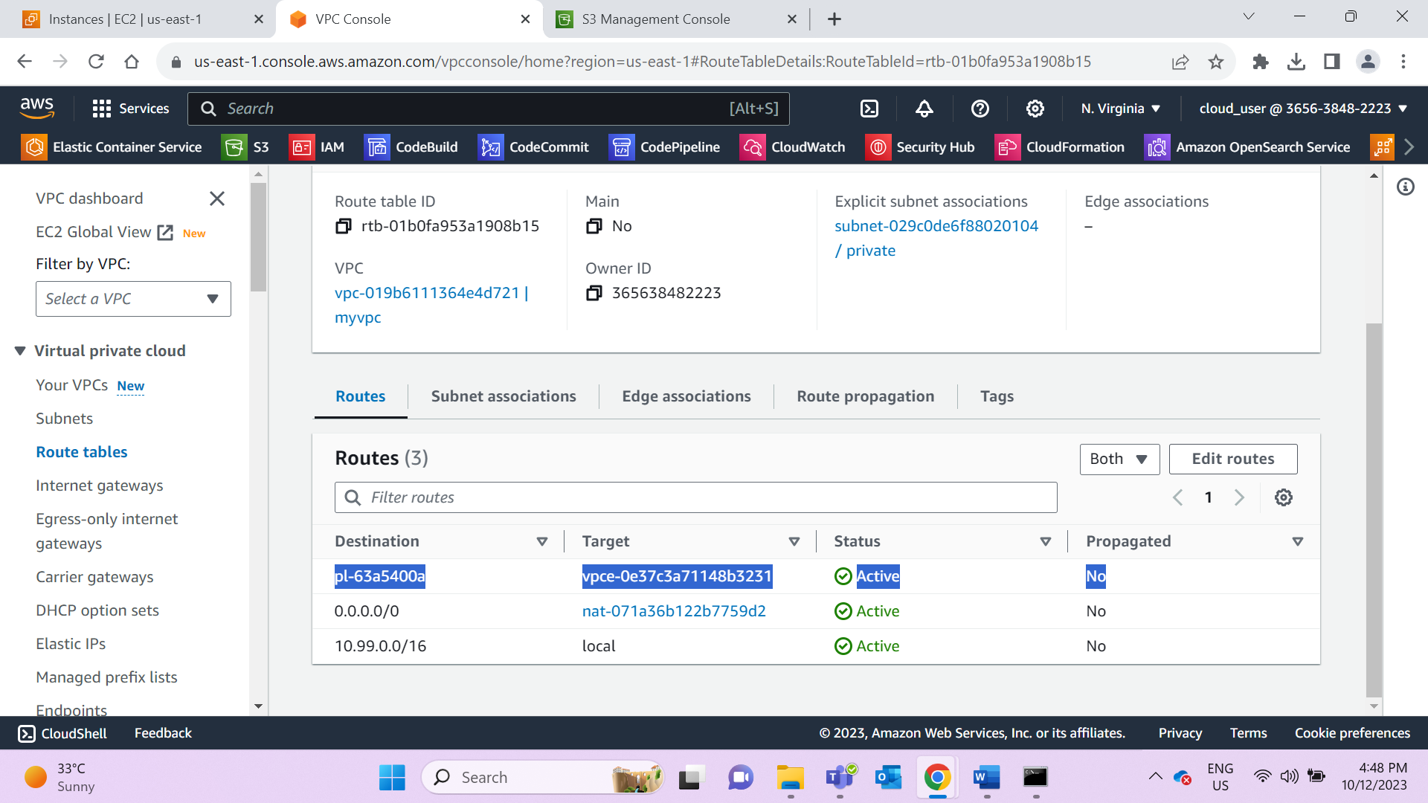

Try access S3 using private EC2 instance via SSh terminal. It should allow without any issues.